Jobs Blueprint Documentation

1-Development Template

Knowledge Base

✅ What is "Development Template" mean?
# Source: AI Source: Provided by: [Data Path: Persons Table -> ID Column: 1, Name_En Column: Motasem Essam] -> From: [ChatGPT] on [10/12/2025]
The Development Template is a structured framework designed to organize, track, and manage software development tasks, code changes, and related resources. It ensures that development activities are documented consistently, making it easier to monitor progress, assign responsibilities, maintain traceability, and facilitate collaboration across teams.

Rules and Guidelines

1-Code Elements

1.1-Rule 1: Pointing to Variable, Function, or Class
# Source: AI Source: Provided by: [Data Path: Persons Table -> ID Column: 1, Name_En Column: Motasem Essam] -> From: [ChatGPT] on [10/12/2025]
Syntax:
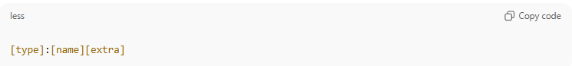
Where:
- type – indicates what you’re pointing to:
  - var → variable
  - func → function
  - class → class

- name – the exact name of the element
  - Use exact casing
- extra – optional, for functions or methods:
  - () → indicates it’s a function call
  - ClassName.methodName() → method of a class

Examples
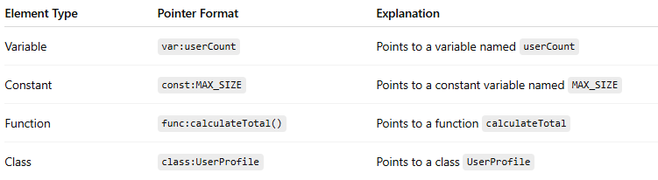
Element Type | Pointer Format | Explanation
Variable | var:userCount | Points to a variable named userCount
Constant | const:MAX_SIZE | Points to a constant variable named MAX_SIZE
Function | func:calculateTotal() | Points to a function calculateTotal
Class | class:UserProfile | Points to a class UserProfile

✅ Rules
- Always use lowercase type prefix: var, func, class
- Include parentheses only for functions or methods
- Use full name with dot notation for methods
- This format works in text, docs, or comments to clearly reference code

1.2-Rule 2: Accessing Methods or Properties from a Class
# Source: AI Source: Provided by: [Data Path: Persons Table -> ID Column: 1, Name_En Column: Motasem Essam] -> From: [ChatGPT] on [10/12/2025]
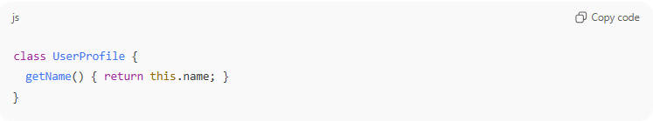
class UserProfile {
getName() { return this.name; }
}

Reference the method as class:UserProfile.func:getName()
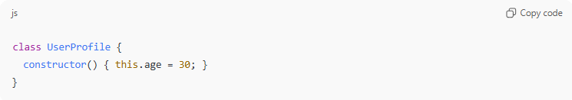
class UserProfile {
constructor() { this.age = 30; }
}

Reference the property as class:UserProfile.prop:age

2-REST API Endpoints

2.1-Rule for Describing REST API Endpoints
# Source: AI Source: Provided by: [Data Path: Persons Table -> ID Column: 1, Name_En Column: Motasem Essam] -> From: [ChatGPT] on [10/12/2025]
Format:
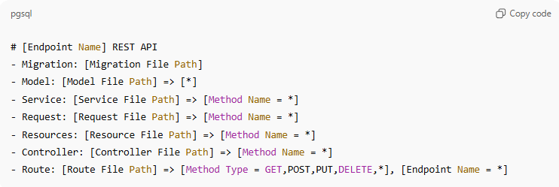
# [Endpoint Name] REST API
- Migration: [Migration File Path]
- Model: [Model File Path] => [*]
- Service: [Service File Path] => [Method Name = *]
- Request: [Request File Path] => [Method Name = *]
- Resources: [Resource File Path] => [Method Name = *]
- Controller: [Controller File Path] => [Method Name = *]
- Route: [Route File Path] => [Method Type = GET,POST,PUT,DELETE,*], [Endpoint Name = *]

Legend:
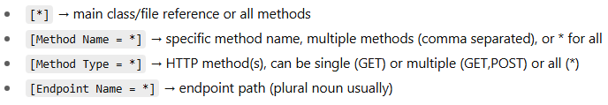
- [*] → main class/file reference or all methods
- [Method Name = *] → specific method name, multiple methods (comma separated), or * for all
- [Method Type = *] → HTTP method(s), can be single (GET) or multiple (GET,POST) or all (*)
- [Endpoint Name = *] → endpoint path (plural noun usually)

Example 1: Governorates REST API (All Methods)
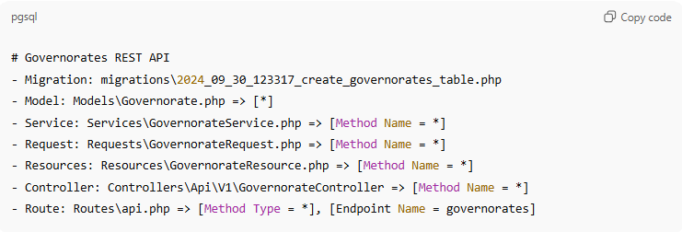
# Governorates REST API
- Migration: migrations\2024_09_30_123317_create_governorates_table.php
- Model: Models\Governorate.php => [*]
- Service: Services\GovernorateService.php => [Method Name = *]
- Request: Requests\GovernorateRequest.php => [Method Name = *]
- Resources: Resources\GovernorateResource.php => [Method Name = *]
- Controller: Controllers\Api\V1\GovernorateController => [Method Name = *]
- Route: Routes\api.php => [Method Type = *], [Endpoint Name = governorates]

Example 2: Cities REST API (Specific Method Type: GET only)
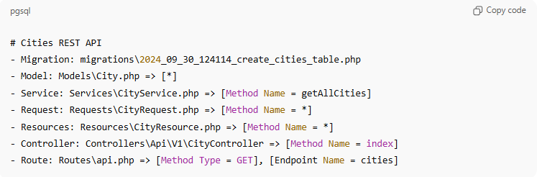
# Cities REST API
- Migration: migrations\2024_09_30_124114_create_cities_table.php
- Model: Models\City.php => [*]
- Service: Services\CityService.php => [Method Name = getAllCities]
- Request: Requests\CityRequest.php => [Method Name = *]
- Resources: Resources\CityResource.php => [Method Name = *]
- Controller: Controllers\Api\V1\CityController => [Method Name = index]
- Route: Routes\api.php => [Method Type = GET], [Endpoint Name = cities]

Example 3: Cities REST API (Group of Methods: GET and POST)
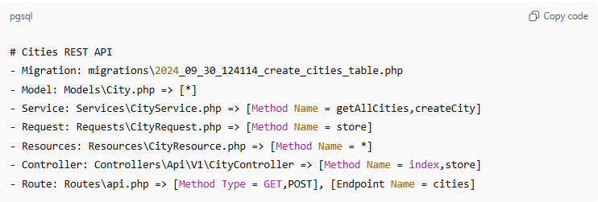
# Cities REST API
- Migration: migrations\2024_09_30_124114_create_cities_table.php
- Model: Models\City.php => [*]
- Service: Services\CityService.php => [Method Name = getAllCities,createCity]
- Request: Requests\CityRequest.php => [Method Name = store]
- Resources: Resources\CityResource.php => [Method Name = *]
- Controller: Controllers\Api\V1\CityController => [Method Name = index,store]
- Route: Routes\api.php => [Method Type = GET,POST], [Endpoint Name = cities]

✅ Rules Added:

- Method Type can be single, multiple (comma separated), or * for all.
- Method Name can be single, multiple (comma separated), or * for all.
- Use this to clearly indicate which methods the route handles and which service/controller methods are linked.

2.2-Routes with Multiple Endpoints
# Source: AI Source: Provided by: [Data Path: Persons Table -> ID Column: 1, Name_En Column: Motasem Essam] -> From: [ChatGPT] on [10/12/2025]
Format:
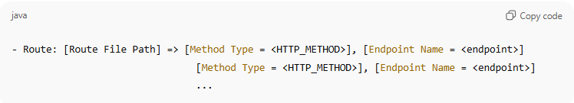
- Route: [Route File Path] => [Method Type = <HTTP_METHOD>], [Endpoint Name = <endpoint>]
[Method Type = <HTTP_METHOD>], [Endpoint Name = <endpoint>]
...
- Each line after the first represents a separate endpoint in the same route file.
- [Method Type] → GET, POST, PUT, DELETE, or * for all
- [Endpoint Name] → the endpoint path

Example: Profile Endpoints
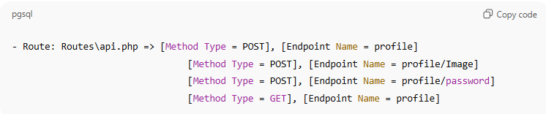
- Route: Routes\api.php => [Method Type = POST], [Endpoint Name = profile]
[Method Type = POST], [Endpoint Name = profile/Image]
[Method Type = POST], [Endpoint Name = profile/password]
[Method Type = GET], [Endpoint Name = profile]

✅ Notes / Rules:
- Use one line per endpoint for clarity.
- You can mix different HTTP methods for the same or different endpoints.
- Works well for grouped related endpoints, e.g., all profile routes.
- Can combine this with method pointer rules for controllers or services:
- Controller: Controllers\Api\V1\ProfileController => [Method Name = update,updateImage,updatePassword,getProfile]

